**SMART STAR EXAMINATIONS BOARD**

**END OF TERM ONE EXAMINATION - 2024**

**MATHEMATICAL CONCEPTS**

**TOP CLASS**

My name is………………………………………

1. **Tick only numbers.**

3 m

Y 10 a

4 c

**15**

**2. Count and write.**

**= ______________**

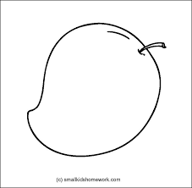 **= _______________**

**= _____**

= _______

**3. Draw balls for the number.**

2 5

1 7

8

0

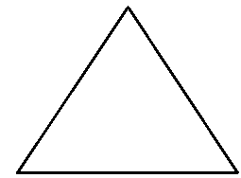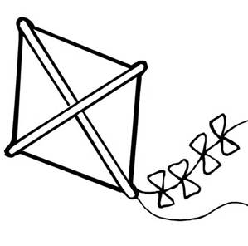**4. Write the first sound.**

___iangle ___ite



__ar ___val

__ectangle

1. **Match correctly**

six 

one

four 

two

1. **Shade for the number.**

6 =

7=

2=

0 =

9=

3=

1. **Write the number after.**

1 ____ 10 ______

5 ____ 8 _______

3 ____ 6 _______

**END**